**Create an ARIMA model for time series forecasting run in python code**

**EX.No:8**

**DATE:**

**AIM:**

To build an ARIMA model for forecasting future values of a time series based on historical data.

**ALGORITHM:**

1. Load the time series data and set the date as the index.
2. Plot the data and check for stationarity.
3. Select ARIMA parameters (p, d, q).
4. Fit the ARIMA model to the data.
5. Forecast future values and visualize the results.

**CODE:**

import pandas as pd

import matplotlib.pyplot as plt

from statsmodels.tsa.arima.model import ARIMA

# Step 1: Load the dataset

file_path = 'Dataset.csv'

data = pd.read_csv(file_path)

# Step 2: Fix the month column by adding a year

data['month'] = data['month'] + '-2020'  # Add dummy year

# Step 3: Convert to datetime

data['month'] = pd.to_datetime(data['month'], format='%d-%b-%Y')

# Step 4: Set date as index

data.set_index('month', inplace=True)

# Step 5: Handle missing values

data['price'] = data['price'].interpolate()

# Step 6: Plot the original time series

plt.figure(figsize=(10, 4))

plt.plot(data['price'], label='Original Time Series')

plt.title('Original Time Series')

plt.xlabel('Date')

plt.ylabel('Price')

plt.legend()

plt.grid(True)

plt.show()

# Step 7: Build and train ARIMA model

# Simple assumption: (p=1, d=1, q=1)

model = ARIMA(data['price'], order=(1, 1, 1))

model_fit = model.fit()

# Step 8: Forecast future values

forecast_steps = 12  # Next 12 months

forecast = model_fit.forecast(steps=forecast_steps)

# Step 9: Plot forecast vs original

plt.figure(figsize=(10, 4))

plt.plot(data['price'], label='Actual')

future_dates = pd.date_range(data.index[-1] + pd.DateOffset(months=1), periods=forecast_steps, freq='MS')

plt.plot(future_dates, forecast, label='Forecast', color='red')

plt.title('Forecast vs Actual')

plt.xlabel('Date')

plt.ylabel('Price')

plt.legend()

plt.grid(True)

plt.show()

**OUTPUT:**

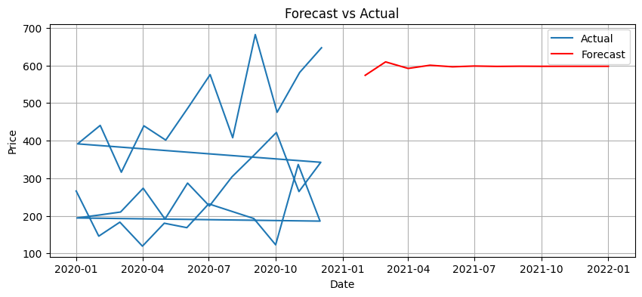

**RESULT:**

Thus the program has been completed and verified successfully.